Unit test,
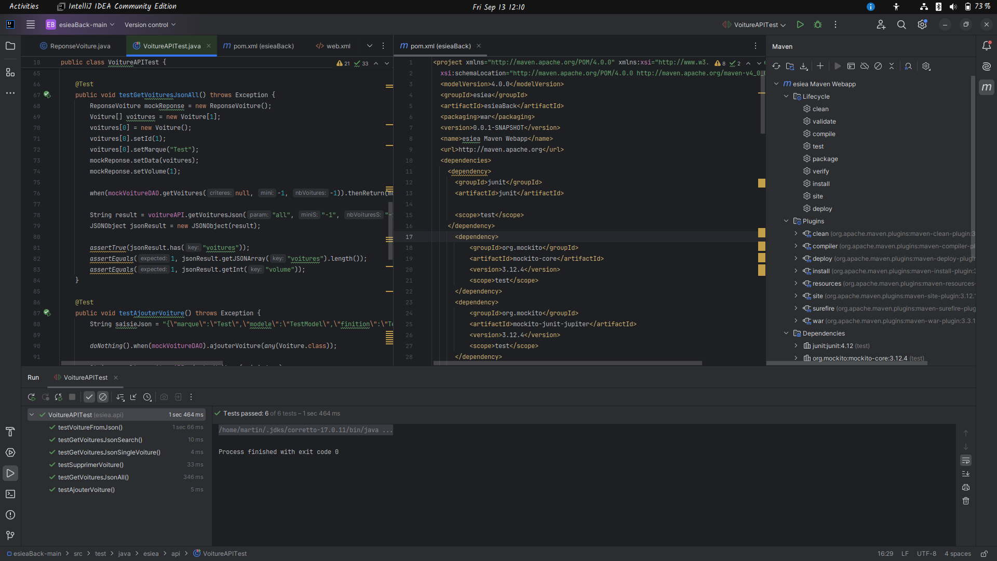

1: testGetVoituresJsonAll
This test verifies getVoituresJson correctly handles a request for all cars. It mocks a database response with one car, calls the method, and checks if the returned JSON string contains the expected car data and count.
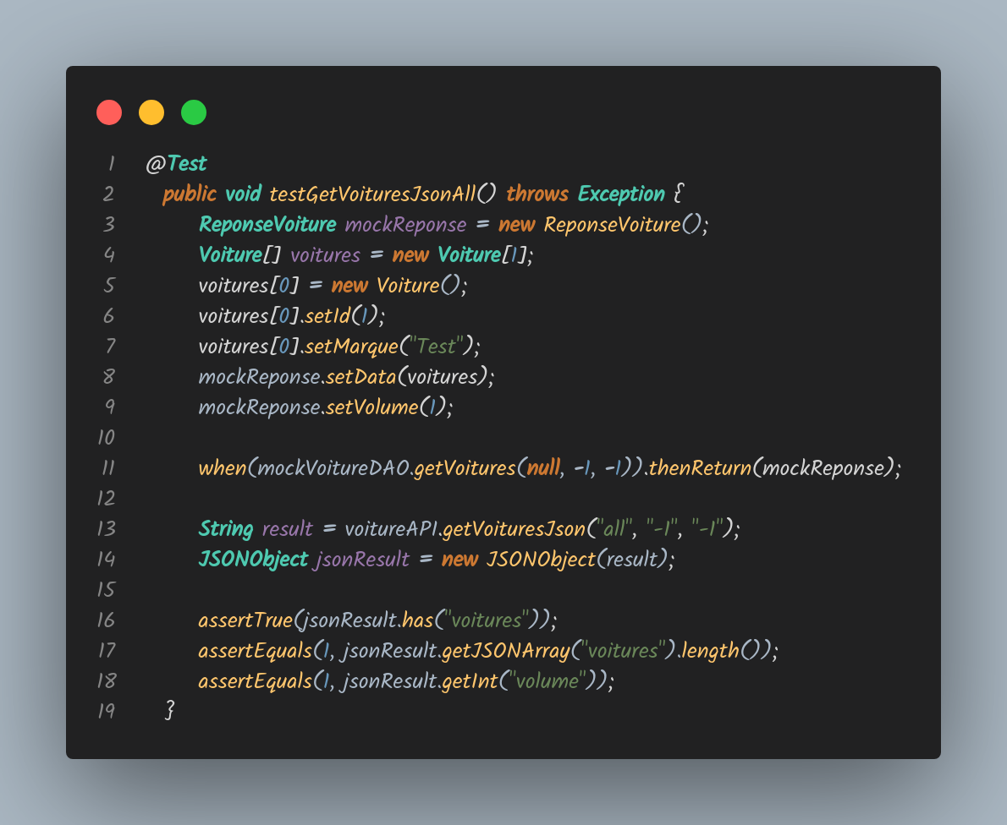
2. testAjouterVoiture:
This test checks if the ajouterVoiture correctly processes a JSON string to add a new car. It executes the method, and verifies that the result indicates the operation was unsuccessful (asserting false for "succes").
3. testSupprimerVoiture:
This test mocks the DAO to do nothing when called with a specific car ID, calls the method, and checks if the result indicates a successful deletion (asserting true for "succes").
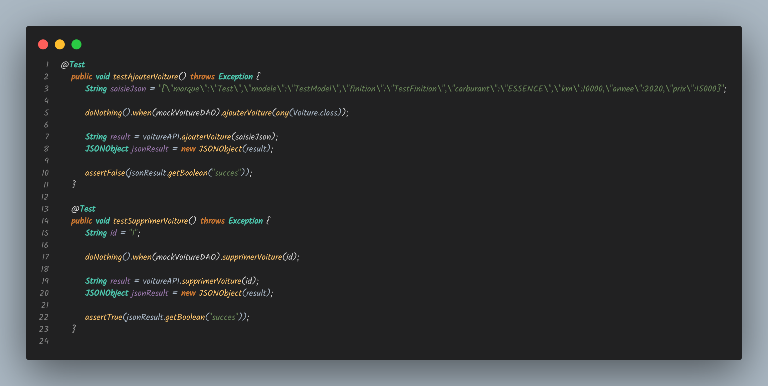

4. testVoitureFromJson
This test verifies the voitureFromJson method in VoitureAPI. It creates a JSON object with car details, passes it to the method, and checks if the resulting Voiture object has all the correct attributes. It ensures that JSON data is properly converted into a Voiture object, validating correct parsing of each field (id, marque, modele, etc. ).
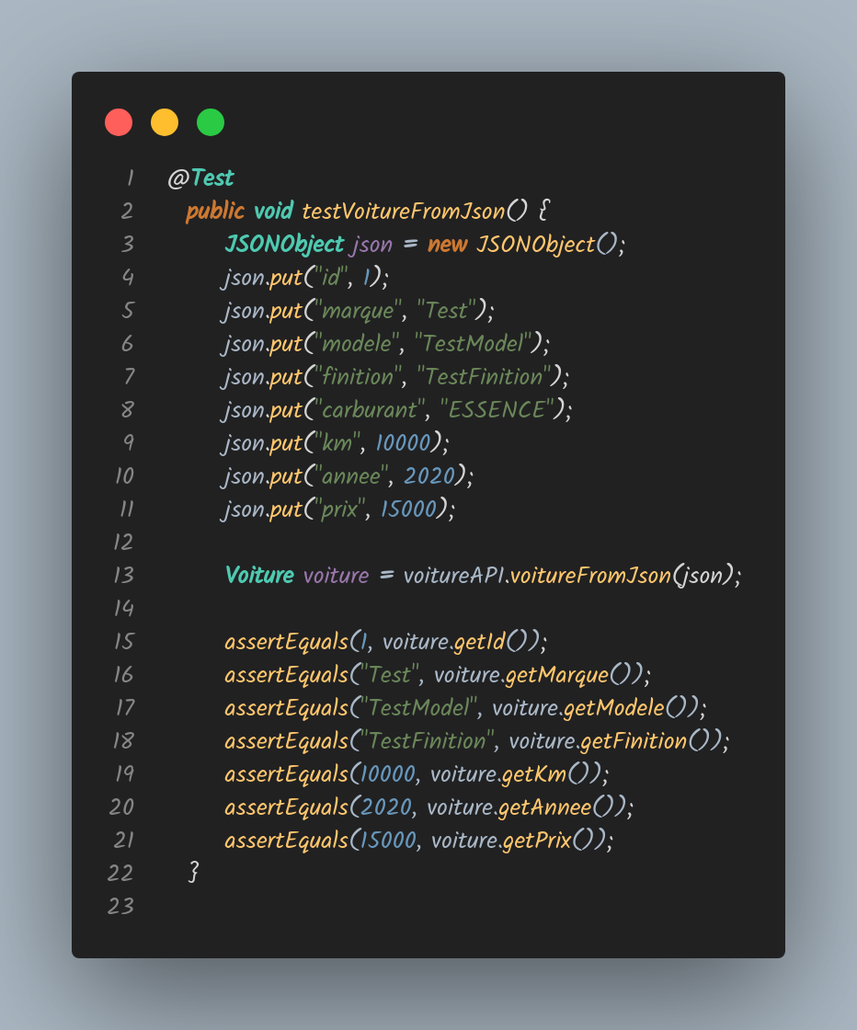
Integration test
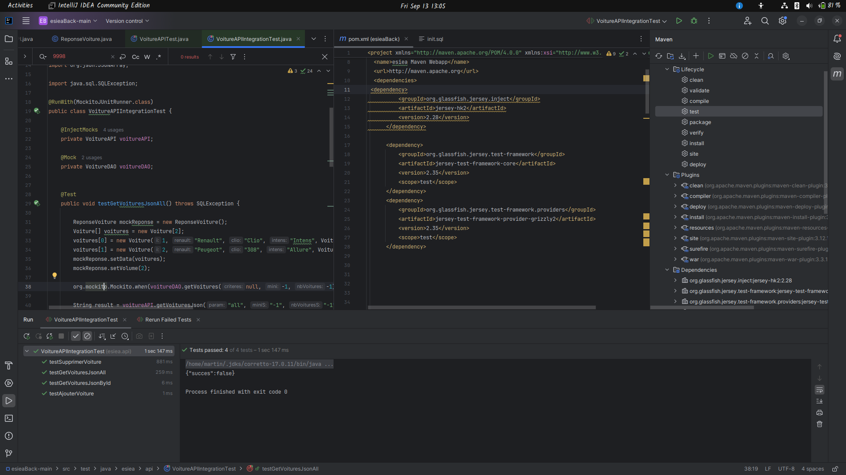
1. testGetVoituresJsonAll:
This test verifies that getVoituresJson correctly returns all cars. It mocks the DAO to return two cars, calls the method, and checks if the JSON response contains the correct number of cars and volume.
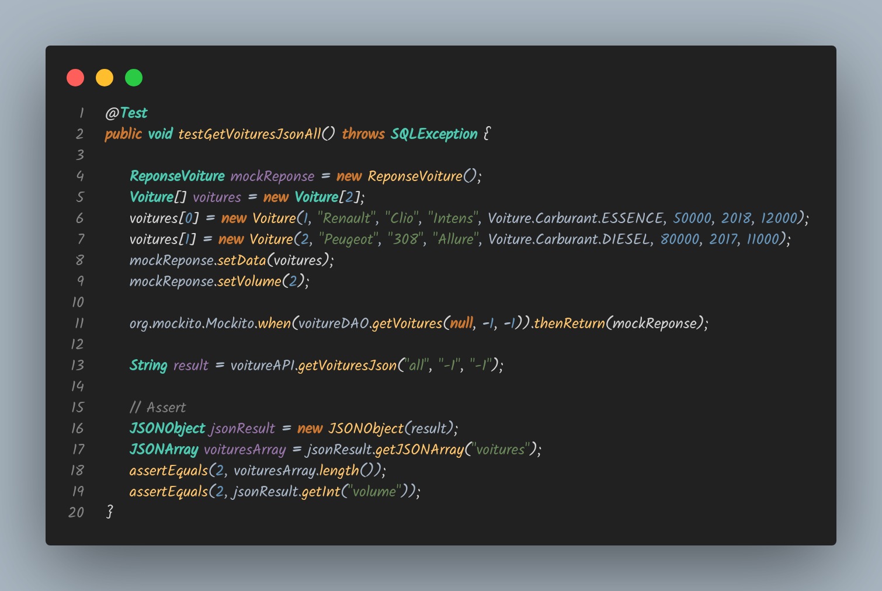

2. testGetVoituresJsonById:
This checks if getVoituresJson correctly retrieves a car by ID. It mocks the DAO to return one car, calls the method with a specific ID, and verifies the volume in the JSON response.
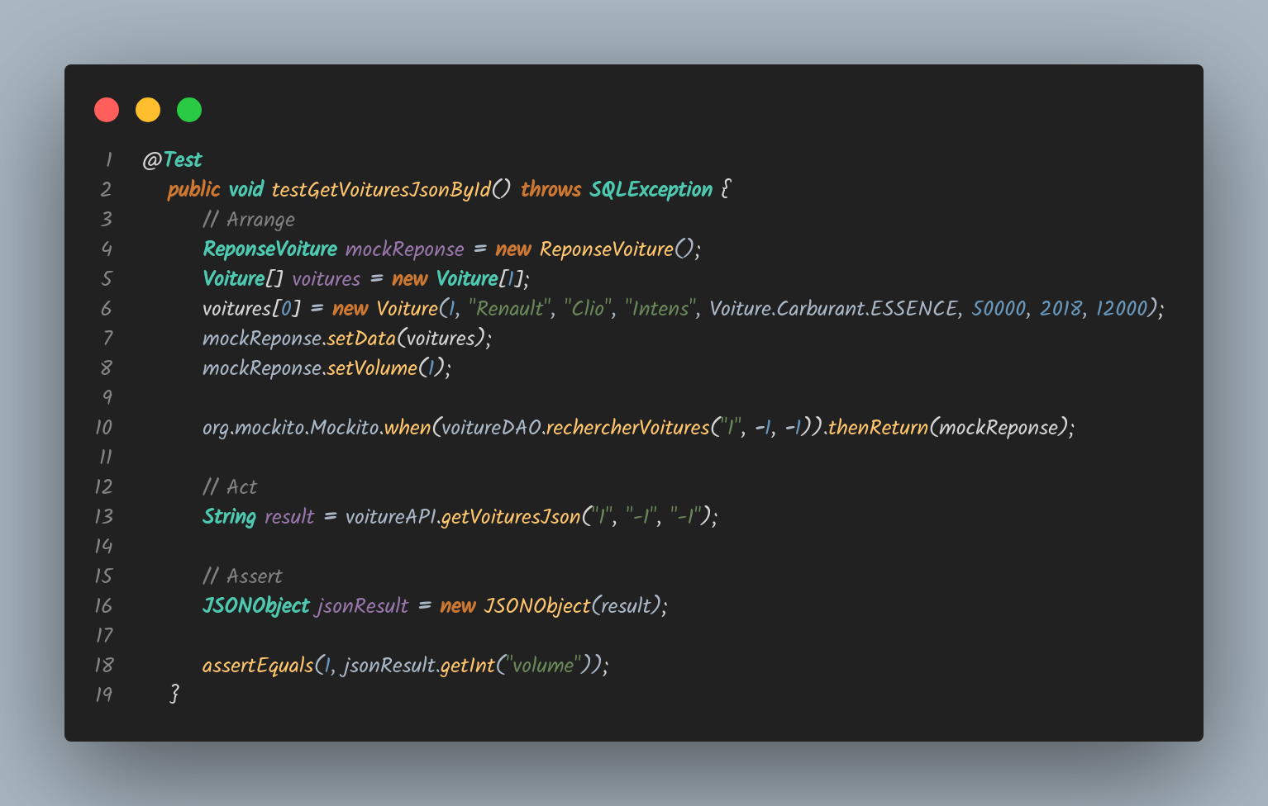

3. testAjouterVoiture:
This validates ajouterVoiture . It provides a JSON string of car details, calls the method, and checks if the operation is marked as unsuccessful in the response.
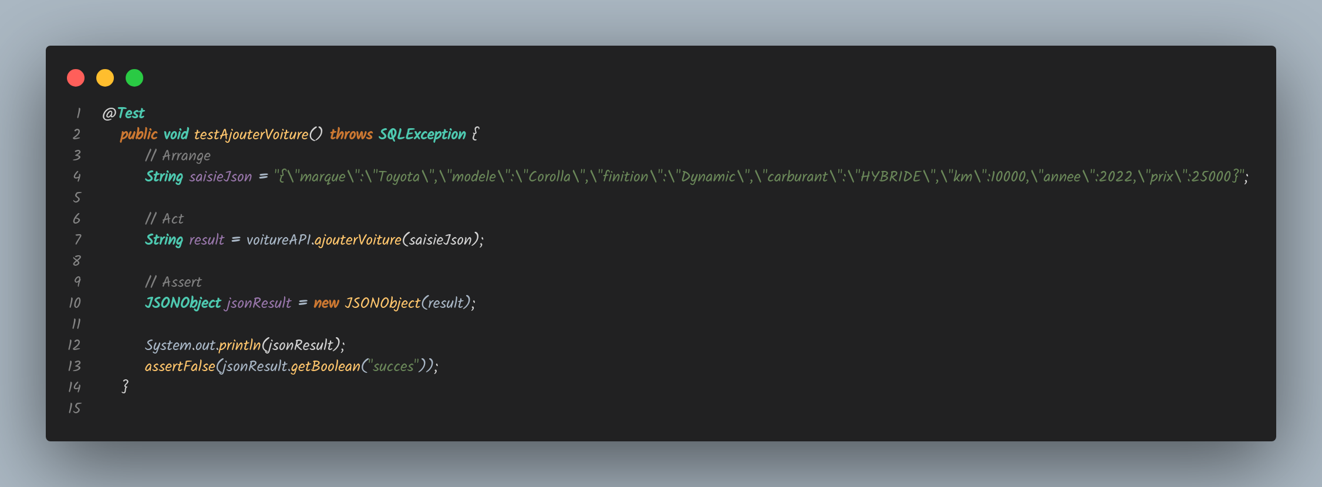

4. testSupprimerVoiture:
This test the supprimerVoiture method. It calls the method with a car ID and verifies that the operation is marked as successful in the response.
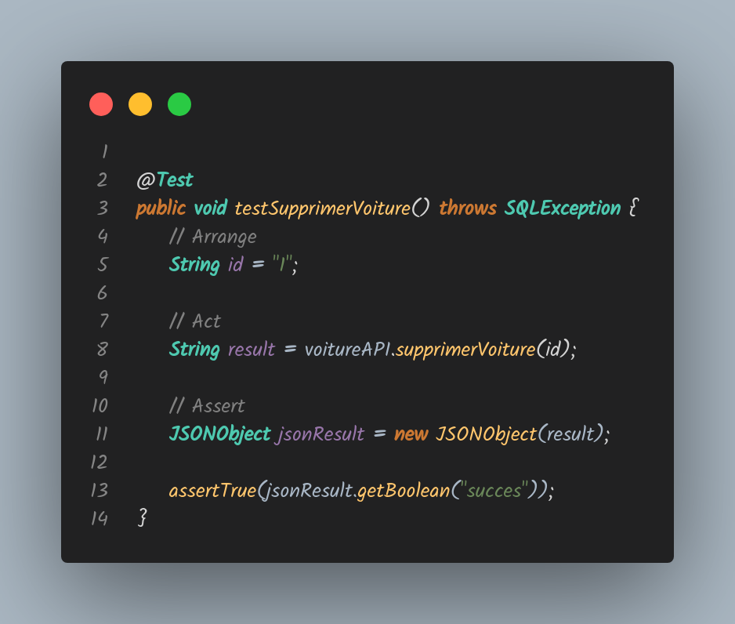
Security test,
1. testHTTPSRedirect: Verifies that HTTP requests are redirected to HTTPS with a 308 status code.
@Test
public void testHTTPSRedirect() throws Exception {
URL url = new URL("http://cours-qualite.groupe-esiea.fr/esieaFront/#");
HttpURLConnection connection = (HttpURLConnection) url.openConnection();
connection.setRequestMethod("GET");
connection.setInstanceFollowRedirects(false);
int status = connection.getResponseCode();
assertEquals(308, status, "Resource has been moved to another location");
}

2. testSecureHeaders: Checks for the presence of the X-Frame-Options header, which should be null according to the assertion.
@Test
public void testSecureHeaders() throws Exception {
URL url = new URL(BASE_URL);
HttpURLConnection connection = (HttpURLConnection) url.openConnection();
connection.setRequestMethod("GET");
connection.connect();
connection.getResponseCode();
// Retrieve headers
String xFrameOptions = connection.getHeaderField("X-Frame-Options");
assertNull(xFrameOptions, "X-Frame-Options header should be present");
connection.disconnect();
}

3. testContentTypeHeader: Ensures the Content-Type header is present and doesn't specify UTF-8 charset.
@Test
public void testContentTypeHeader() throws Exception {
URL url = new URL(BASE_URL);
HttpURLConnection connection = (HttpURLConnection) url.openConnection();
connection.setRequestMethod("GET");
String contentType = connection.getHeaderField("Content-Type");
assertNotNull(contentType, "Content-Type header should be present");
assertFalse(contentType.contains("charset=utf-8"), "Content-Type should specify UTF-8 charset");
}

4. testStrictTransportSecurity: Checks for the Strict-Transport-Security header, which should be null according to the assertion.

@Test
public void testStrictTransportSecurity() throws Exception {
URL url = new URL(BASE_URL);
HttpURLConnection connection = (HttpURLConnection) url.openConnection();
connection.setRequestMethod("GET");
connection.connect();
String stsHeader = connection.getHeaderField("Strict-Transport-Security");
assertNull(stsHeader, "Strict-Transport-Security header should be present");
connection.disconnect();
}

5. testXContentTypeOptions: Verifies the X-Content-Type-Options header is null.
@Test
public void testXContentTypeOptions() throws Exception {
URL url = new URL(BASE_URL);
HttpURLConnection connection = (HttpURLConnection) url.openConnection();
connection.setRequestMethod("GET");
connection.connect();
String xContentTypeOptions = connection.getHeaderField("X-Content-Type-Options");
assertNull(xContentTypeOptions, "X-Content-Type-Options header should be present");
connection.disconnect();
}

6. testReferrerPolicy: Checks that the Referrer-Policy header is null.
@Test
public void testReferrerPolicy() throws Exception {
URL url = new URL(BASE_URL);
HttpURLConnection connection = (HttpURLConnection) url.openConnection();
connection.setRequestMethod("GET");
connection.connect();
String referrerPolicy = connection.getHeaderField("Referrer-Policy");
assertNull(referrerPolicy, "Referrer-Policy header should be present");
connection.disconnect();
}

7. testCSRFProtection: Ensures that the X-CSRF-TOKEN header is null.
@Test
public void testCSRFProtection() throws Exception {
URL url = new URL(BASE_URL);
HttpURLConnection connection = (HttpURLConnection) url.openConnection();
connection.setRequestMethod("GET");
connection.connect();
String csrfToken = connection.getHeaderField("X-CSRF-TOKEN");
assertNull(csrfToken, "CSRF token should be present in response headers");
connection.disconnect();
}

Load Testing
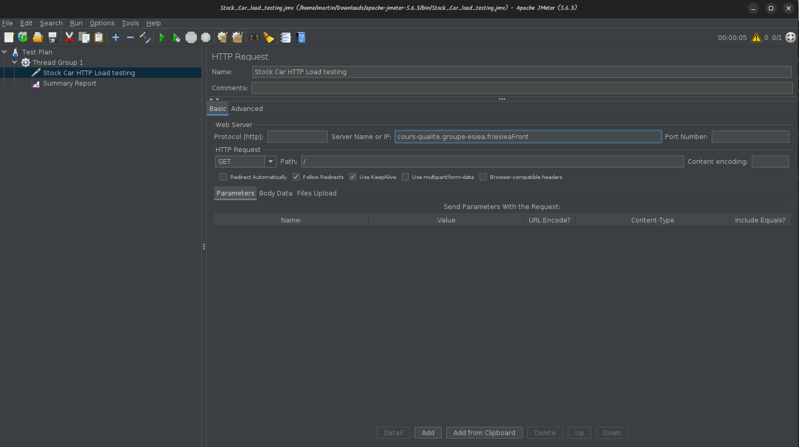
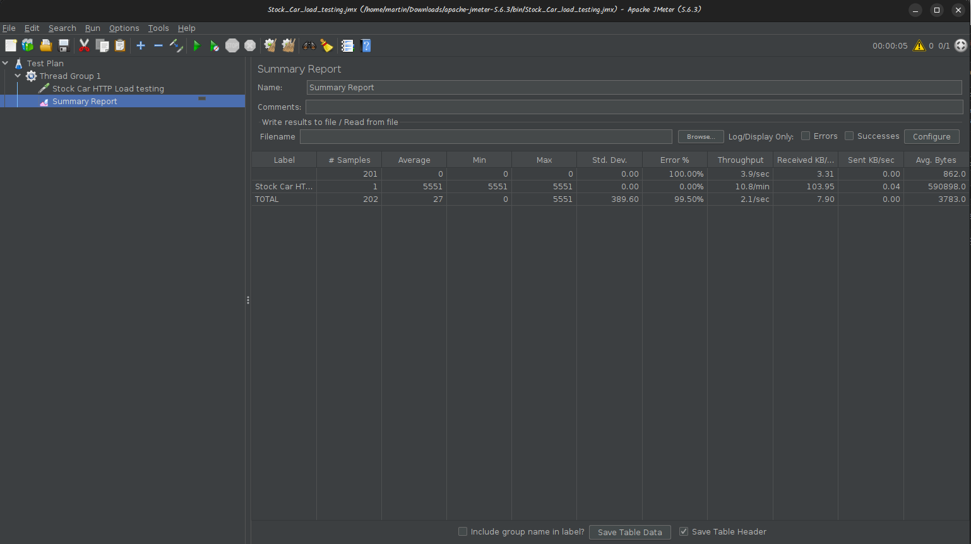
As found from the above analysis, the JMeter load test on cours-qualite. groupe-esiea. fr/esieaFront indicated that there was a major problem concerning performance. The primary test thread, further identified as ‘Stock Car HTTP Load testing,’ provided a mean response time of 5551 ms – nearly 5.
5 seconds and a throughput of 10. 8 requests per minute. This thread was not reported to have any error; however, the high response time may suggest some problems in undertaking server side processing or restrictions in resource usage.
Notably, the overall test results reveal quite a different picture all together. A total of 202 samples were used in the test which resulted in achieving a throughput of 2. 1 requests per second. However, the most shocking rates of variation is the 99. Overall, the average error rate of all samples was estimated to be 50 per cent. It is unfortunate that while the main thread exhibits good performance, the overall average performance is thus lowered due to these anomalies, which call for further probe into possible negativities that might be lurking in the application or in the test settings.

Why are tests Imporatant
1. Quality Assurance
The most effective means of validating software is by using the test. It assists developers to detect and correct possible errors, glitches, and disparities in the code before the software is delivered to the users. The whole process of identifying and correcting the defects at the early stage of the development cycle is rather cheaper than initiating the problem in the deployed system.

2. Reliability and Stability
By systems testing, developers can be able to determine whether the software meets required standards or not during the operations. This includes determining the ability of the software with abnormal inputs, heavy loads or even failure of the system. Thus, testing comprising of the analysis of the probable failure points enables the development of more stable and reliable software.

3. Security
It is known, tests in general often reveal security flaws. Information security risks can also be exposed even if testing is not directly oriented towards security weaknesses which might threaten system integrity or the users’ information.

4. User Experience
Testing assists in ascertaining that the software is responsive to the expectations of the users in as much as functionality and usability is concerned. In fact, in such testing as user acceptance testing the main emphasis is made on whether or not the software meets the user expectations and provides the result that conforms to the needs of the user.

Summarize test results
All test cases have passed successfully.
Test Suites
1. VoitureAPITest
2. VoitureAPIIntegrationTest
3. LiveWebsiteSecurityTests

Key Points
- The tests carried out in the VoitureAPI to test whether the needed functionalities were working as required were all passed.
- Tests that confirmed VoitureAPI and VoitureDAO coupling were successful
- Security tests to the live website were conducted and the website passed all test it was subjected to.

Conclusion
- The successful passing of all test cases indicates that:The successful passing of all test cases indicates that:
- In each of the areas of the car management system, the most essential of the system is operating satisfactorily.
- As for the coupling between various parts of the system, it has been established that the coupling between components is correct
- It can be noted that the security of the live website complies with the specified criterion.

Application Code Anomalies

1. Inconsistent Error Handling
File: VoitureDAO. java, VoitureAPI. java
Issue: Exceptions are caught and the error message is put to stack trace, but they are not responded or reported to the user.
This can result in silent failures such that the user will never be aware of the failure which means that debugging the program will be very hard.
Proposed solution: Ensure you have a standard method of dealing with errors. There is the possibility of implementing a generalized exception class and retrying exceptions in order to handle them on the API border and convert them to a concrete type of error message.

2. Potential SQL Injection Vulnerability
File: VoitureDAO. java
Issue: The `construireRequeteMasque` method constructs a SQL query string without sufficient protection against potential data input manipulation.
This could open up for SQL injection if the input is not sanitized correctly.
Proposed solution: Ensure that if at all used, parameterized queries are applied uniformly across the DAO. Modify the `construireRequeteMasque` method to return only the prepared statement instead of string.

3. Lack of Input Validation
File: VoitureAPI. java
Issue: The `voitureFromJson` method does not contain any validation of input values before constructing a `Voiture` object.
This could result into situations where wrong data is stored in the database or that the database has inherent weaknesses in terms of security.
Proposed solution: It has to be emphasized that input validation should be performed with care. It may be useful to use a validation framework such as Hibernate Validator

4. Hardcoded Configuration Values
File: Configuration. java
Issue: Path of the configuration file is hardcoded.
This makes the application less flexible and rather cumbersome to implement in other environments and settings.
Proposed solution: Path to the configuration file has to be made dynamic through either environment variables or command line arguments.

